**Milestone5**

|  |  |
| --- | --- |
| Project Title: POS System | Project Group #: 11 |
| Instructor: Benjamin Yu  Students | Set ACIT 1A |
| Yu PoYing | A00932303 |
| Hampson Andrew | A00954302 |
| Chen Kuei Yuan | A00962767 |
| Liu Feng | A00932532 |

1. We have achieved designing the PO system by writing the proposal, identifying the stakeholders, considering the requirements of the PO system, constructing basic ER diagram, improving our ER diagram and normalizing it, defining data dictionary, creating sample database and sample data. There many difficulties we have encountered in each stages of designing our PO system. We applied the knowledge learn from the course to solve the essential problem encountered in designing and improving our PO system. Also, we setup regular meetings every weeks to keep information well shared between members so everyone has the same level of understanding about our project. Cloud documents storage tools and project progress managing tools helps a lot to coordinate our project progress between members. We would add more constrains for our PO system, also we will add more attributes or create new entities to our PO system especially regarding the materials required in film industry.

MileStone 1

**Purchase Ordering System**

* summary descriptions of information required from the database

In companies that purchase a large and varied amount of primary materials, a dedicated and robust purchase ordering system is required to track purchases, help inform future purchases, and track suppliers,  orders and outstanding invoices.

Most primary material purchases in industry are not completed by the time the goods are delivered. In fact, it can be weeks until payment reaches the supplier. In most cases, the supplier issues an invoice which must work its way through various departments before a cheque can be mailed. It’s easy for purchases to be made, then forgotten about until hefty fines accrue. Pencil and paper systems are inefficient and make errors easy, so the move to computer services is an obvious choice.

In the film industry, the variety of purchases is staggering. One production company can consult with thousands of suppliers, from anywhere from construction materials to clothing to electrical equipment. Most of these companies have multiple employees across several departments dedicated only to buying material. The requests for stock from all other employees come to these purchasers, who then communicate with relevant suppliers. They also handle the invoices and purchase orders created by the transaction.

**The stakeholders:**

These stakeholders are more concerned with the analysis of data and the information it contains

**Management:** Management needs a global view of outstanding accounts, inventory and, for accountability, a record of which employees requested which materials.

**Accounting:** Accounting needs a record of every invoice and a sum of what is owed to which suppliers.

Conversely, these stakeholders are interested in the creation, accumulation and organization of data entities.

**Purchasers:** The purchaser needs to be able to create POs, to list suppliers by what they sell, find information about suppliers, such as address, prices, etc.

**Employees:** Employees need to be able to request that certain items or styles of items be bought.

**Suppliers:** Suppliers must be able to change what products are listed in the database, what invoices are created.

There would be many EMPLOYEES requesting many PURCHASE ORDERS. One PURCHASER would create each PURCHASE ORDER. A SUPPLIER would provide many INVOICES, each INVOICE specifying many INVENTORY items. One PURCHASE ORDER contains one or many INVOICES.

(We are making the assumption that the suppliers, Production Company, and other parties all have access to and are willing to use the same database. In reality this would be infeasible and near-impossible to implement.)

**Gantt Chart**

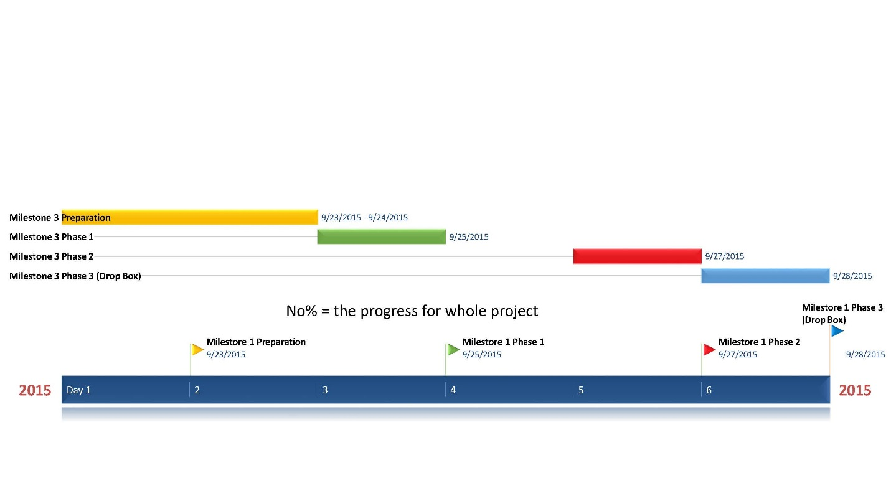

Document Information

|  |  |  |  |
| --- | --- | --- | --- |
| Project Name: | **ACIT1630 DB Project** | | |
| Project Manager: | York Liu |
| Prepared By: | York Liu |  |  |

1. Meeting Specifics

|  |  |  |  |  |  |  |
| --- | --- | --- | --- | --- | --- | --- |
| Type: | **Milestone1- phase 1** | | | | | |
| Purpose: | Ongoing information sharing and project status update | | | | | |
| Meeting Date: | 2015-09-25 | Start Time: | 5:30pm | | End Time: | 6:30pm |
| Meeting Host: | Zach | | Location: | Free table in Second floor SW 1 | | |
| Minute Taker: | York | |  |  | | |

1. Meeting Attendees

| Name |  | Attendance status | Position | Progress |
| --- | --- | --- | --- | --- |
| Andrew | | Yes | Project Leader | 10% |
| Zach Yu |  | Yes | Coordinator | 10% |
| Peter | | Yes | Project Leader | 10% |
| York |  | Yes | Time Scheduler | 10% |

1. Agenda

| Id | Topic | Presenter | Times |
| --- | --- | --- | --- |
| 1 | Two Proposal   |  | | --- | |  | | All team member | 2015-09-25 |

1. Meeting Status Update and Results

Results Table

| No. | Subject/Description | Owner | Status & Progress |
| --- | --- | --- | --- |
| 1 | Read milestone 1 | All team member | Done |

Document Information

|  |  |  |  |
| --- | --- | --- | --- |
| Project Name: | **ACIT1630 DB Project** | | |
| Project Manager: | York Liu |
| Prepared By: | York Liu |  |  |

1. Meeting Specifics

|  |  |  |  |  |  |  |
| --- | --- | --- | --- | --- | --- | --- |
| Type: | **Milestone1- phase 2** | | | | | |
| Purpose: | Ongoing information sharing and project status update | | | | | |
| Meeting Date: | 2015-09-27 | Start Time: | 5:30pm | | End Time: | 6:30pm |
| Meeting Host: | Zach | | Location: | Free table in Second floor SW 1 | | |
| Minute Taker: | York | |  |  | | |

2.Meeting Attendees

| Name |  | Attendance status | Position | Progress |
| --- | --- | --- | --- | --- |
| Andrew | | Yes | Project leader | 60% |
| Zach Yu |  | Yes | Coordinator | 60% |
| Peter | | Yes | Project leader | 60% |
| York |  | Yes | Time Scheduler | 60% |

3.Agenda

| Id | Topic | Presenter | Time/Status |
| --- | --- | --- | --- |
| 1 | Library system | Peter | 2015-09-27 |
| 2 | POS system | Andrew | 2015-09-27 |

4.Meeting Status Update and Results

Results Table

| No. | Subject/Description | Owner | Status & Process |
| --- | --- | --- | --- |
| 1 | Milestone 1 update  Two Proposal discussion | All team member | 60% finished |
| 2 | First version of POS system and first version of Library system | All team member | In process |

Document Information

|  |  |  |  |
| --- | --- | --- | --- |
| Project Name: | **ACIT1630 DB Project** | | |
| Project Manager: | York Liu |
| Prepared By: | York Liu |  |  |

1.Meeting Specifics

|  |  |  |  |  |  |  |
| --- | --- | --- | --- | --- | --- | --- |
| Type: | **Milestone1- phase 3** | | | | | |
| Purpose: | Ongoing information sharing and project status update | | | | | |
| Meeting Date: | 2015-09-28 | Start Time: | 5:30pm | | End Time: | 6:30pm |
| Meeting Host: | Zach | | Location: | Meeting Room-2515-SW01 | | |
| Minute Taker: | York | |  |  | | |

2.Meeting Attendees

| Name |  | Attendance status | Position | Progress |
| --- | --- | --- | --- | --- |
| Andrew | | Yes | Project Leader | 100% |
| Zach Yu |  | Yes | Coordinator | 100% |
| Peter | | Yes | Project Leader | 100% |
| York |  | Yes | Time Scheduler | 100% |

3.Agenda

| Id | Topic | Presenter | Time/Status |
| --- | --- | --- | --- |
| 1 | project update | All team member | 2015-09-28 |

4.Meeting Status Update and Results

Results Table

| No. | Subject/Description | Owner | Status & Progress |
| --- | --- | --- | --- |
| 1 | Milestone 1 update  Two Proposal discussion | All team member | Done |
| 2 | First version of POS system and first version of Library system | All team member | Done |

MileStone 2  
  
**A.Detailed Descriptions of Stakeholders**

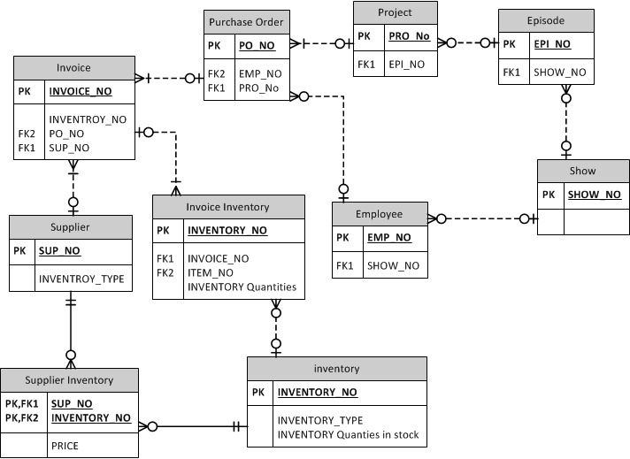

 In our purpose, there are four major stakeholders.

1. Management: People who want to see details, control the flow of money, and make decisions, such as CEOs, directors, and coordinators. It also includes accountants, who are responsible for dealing with financial problems, and production designers, who are responsible for the progress of every project. In addition, Managers also need to know who is in charge of the projects. The Managers only need to periodically check the database data, to analyse the preparedness and view the orders and money that is currently owed.

2.Employees  deal with materials. They are in charge of real needs for film. They work for different projects and require different materials. Employees decide what materials are needed based on the project. They must acquire materials under project’s and episode’s budget.

3. Purchasers, a sub-type of employees, scout out potential suppliers and order materials in for projects. They search for suppliers who provide what is required and compare around to find the best deals between suppliers. They would also use this database to review their past purchase records, budgets they have spent, and shipping states.

4. Suppliers service the material from outside of movie industry. They want to get paid by selling their goods. They would update their inventory to suit the needs of  their customers; quickly acquire information of orders, and prepare invoice for purchasers.

* write out 12 user stories on what the stakeholders would want to do with the database

1. As an accountant, I want to be able to see all outstanding(unpaid) invoices.
2. As a manager, I want to know where our budgets goes.
3. As a purchaser, I want to create and manage purchase orders (database access).
4. As a purchaser, I want to know the suppliers’ types
5. As a purchaser, I want to see my previous orders.
6. As a purchaser, I want to have many purchases containing in one order.
7. As an employee, I want to know the shipping states of my order.
8. As a supplier, I want to know when is the order made.
9. As a supplier, I need to upload the newest  product information.
10. As a supplier, I want to know how many items i need to delivery per day.
11. As a manager, I want to see what department an employee belongs to.
12. As an employee, I want to know if supplier has enough quantity of certain item that I want to purchase.

### B.Data Requirement (what data is needed to supply the information required by users)

Data is provided from physical artifacts, i.e. Purchase Orders, Invoices, Start Slips, Budget Alerts, Scene Breakdowns, Tech Surveys etc. The database serves as a compact file record and quick access for these hundreds of relevant documents. They are

### This database requires its users to provide their own data. People who belong to movie industry need to provide their personal data, project data, and their needs of materials. Suppliers have to provide their product data and store data. You combine data from both sides to form this PO database system. Users could be benefit from this database system. They are able to see information like price comparison between suppliers, how much budget is left, where the money goes, how many items are in stock, and who is in charge of a certain program. Different functions could be useful to different users.C. Project Planning

In group 11, we have a regulative meeting every Wednesday at 14:30-15:30. If we don't get on schedule, we will add more meeting time on Thursday and Friday afternoon in the due day week.

For the basic responsibilities  affiliation, Andrew is the project leader. He designed the major part of database structure and is the final editor. Additionally, Peter (Kuei Yuan) will be the second hand for the project designing. After the discussion in the meeting, Andrew and Peter would develop major new process for the milestone.  Zach (PoYing) contacts all the group members and inspects the process of the group members.  He also need to re-edit old milestones from feedback and new progress.  York ( Feng) will build the Gantt chart and takes down the meeting records.

In our group, we use facebook messages to contact each other. Importantly, we use the google drive to save and share data between group members. Therefore, we can see everyone’s progress immediately. However, face to face meetings are very important to us. We establish more great ideas while we are discussing the topic. Also, we coordinate the team to prevent delays.

**Gantt Chart**

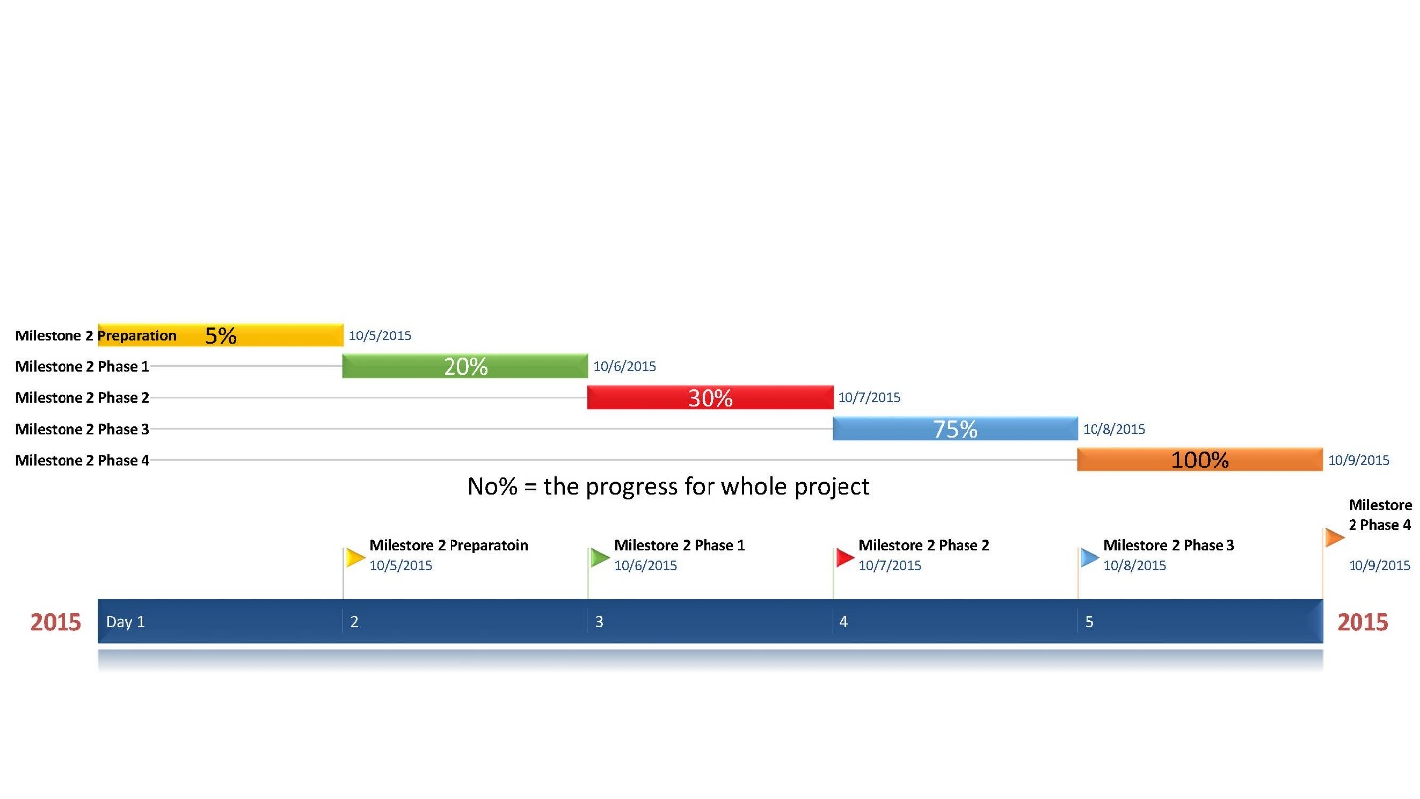

Document Information

|  |  |  |  |
| --- | --- | --- | --- |
| Project Name: | **ACIT1630 DB Project** | | |
| Project Manager: | Zach |
| Prepared By: | Zach |  |  |

1. Meeting Specifics

|  |  |  |  |  |  |  |
| --- | --- | --- | --- | --- | --- | --- |
| Type: | **Milestone2- phase 1** | | | | | |
| Purpose: | Ongoing information sharing and project status update | | | | | |
| Meeting Date: | 2015-10-06 | Start Time: | 5:30pm | | End Time: | 6:30pm |
| Meeting Host: | Zach | | Location: | Free table in Second floor SW 1 | | |
| Minute Taker: | York | |  |  | | |

1. Meeting Attendees

| Name |  | Attendance status | Position | Progress |
| --- | --- | --- | --- | --- |
| Andrew | | Yes | Team Leader | 20% |
| Zach Yu |  | Yes | Coordinator | 20% |
| Peter | | Yes | Team Member | 20% |
| York |  | Yes | Time Scheduler | 20% |

1. Agenda

| Id | Topic | Presenter | Times |
| --- | --- | --- | --- |
| 1 | Assign the task for each team member   |  | | --- | |  | | Zach and Andrew | 2015-10-06 |
| 2 | Append any updates to the detailed proposal   |  | | --- | |  | | Zach | 2015-10-06 |

1. Meeting Status Update and Results

Results Table

| No. | Subject/Description | Owner | Status & Progress |
| --- | --- | --- | --- |
| 1 | Review milestone 1 and 2 | All team member | Done |
| 2 | Make decision for each role of group member in milestone2  A, Zach will charge of part 3  B, Andrew will charge of part 1  C, Peter will charge of part 3  D, Each group member will provide 3 user stories | All team member | In process |

Document Information

|  |  |  |  |
| --- | --- | --- | --- |
| Project Name: | **ACIT1630 DB Project** | | |
| Project Manager: | York Liu |
| Prepared By: | York Liu |  |  |

1. Meeting Specifics

|  |  |  |  |  |  |  |
| --- | --- | --- | --- | --- | --- | --- |
| Type: | **Milestone2- phase 2** | | | | | |
| Purpose: | Ongoing information sharing and project status update | | | | | |
| Meeting Date: | 2015-10-7 | Start Time: | 5:30pm | | End Time: | 6:30pm |
| Meeting Host: | Zach | | Location: | Free table in Second floor SW 1 | | |
| Minute Taker: | York | |  |  | | |

2.Meeting Attendees

| Name |  | Attendance status | Position | Progress |
| --- | --- | --- | --- | --- |
| Andrew | | Yes | Team Leader | 30% |
| Zach Yu |  | Yes | Coordinator | 30% |
| Peter | | Yes | Team Member | 30% |
| York |  | Yes | Time Scheduler | 30% |

3.Agenda

| Id | Topic | Presenter | Time/Status |
| --- | --- | --- | --- |
| 1 | Review the feedback about milestone 1 from instructor Benjamin | Zach | 2015-10-07 |

4.Meeting Status Update and Results

Results Table

| No. | Subject/Description | Owner | Status & Process |
| --- | --- | --- | --- |
| 1 | Milestone 2 update  A, add 12 user stories | All team member | Finished |
| 2 | Part A, B, C discussion | All team member | In process |

Document Information

|  |  |  |  |
| --- | --- | --- | --- |
| Project Name: | **ACIT1630 DB Project** | | |
| Project Manager: | York Liu |
| Prepared By: | York Liu |  |  |

1.Meeting Specifics

|  |  |  |  |  |  |  |
| --- | --- | --- | --- | --- | --- | --- |
| Type: | **Milestone2- phase 3** | | | | | |
| Purpose: | Ongoing information sharing and project status update | | | | | |
| Meeting Date: | 2015-10-08 | Start Time: | 5:30pm | | End Time: | 6:30pm |
| Meeting Host: | Zach | | Location: | Meeting Room-2515-SW01 | | |
| Minute Taker: | York | |  |  | | |

2.Meeting Attendees

| Name |  | Attendance status | Position | Progress |
| --- | --- | --- | --- | --- |
| Andrew | | Yes | Team Leader | 80% |
| Zach Yu |  | Yes | Coordinator | 80% |
| Peter | | Yes | Team Member | 70% |
| York |  | Yes | Time Scheduler | 70% |

3.Agenda

| Id | Topic | Presenter | Time/Status |
| --- | --- | --- | --- |
| 1 | Final Discussion | All team member | 2015-10-08 |
| 2 | project update | All team member | 2015-10-08 |

4.Meeting Status Update and Results

Results Table

| No. | Subject/Description | Owner | Status & Progress |
| --- | --- | --- | --- |
| 1 | A, Create online document for DB group ;  B, Share new edited with milestone2;  C, Zach will work with Peter to finish ERD  D, Zach will update the entity somewhat; | Zach | A, Done  B, Done  C, in process  D, in process |
| 2 | A, Update progress for each task ;  B, Gantt chart building is still on the way;  C, Report every cases happened in meeting; | York | A, Done  B, in process |
| 3 | Show and explain the relationship about each entity for the part of draw ERD, It includes PO Request, invoice, purchaser, supplier, inventory; | Peter | in process |
| 4 | A, Share understanding about whether or not the entity is necessary to add in the ERD;  B, Andrew will build relationship on the basis of Zach’s entity | Andrew | A, Done  B, in process |

Document Information

|  |  |  |  |
| --- | --- | --- | --- |
| Project Name: | **ACIT1630 DB Project** | | |
| Project Manager: | York Liu |
| Prepared By: | York Liu |  |  |

1.Meeting Specifics

|  |  |  |  |  |  |  |
| --- | --- | --- | --- | --- | --- | --- |
| Type: | **Milestone2- phase 4** | | | | | |
| Purpose: | Ongoing information sharing and project status update | | | | | |
| Meeting Date: | 2015-10-09 | Start Time: | 5:30pm | | End Time: | 6:30pm |
| Meeting Host: | Zach | | Location: | Meeting Room-2515-SW1 | | |
| Minute Taker: | York | |  |  | | |

2.Meeting Attendees

| Name |  | Attendance status | Position | Progress |
| --- | --- | --- | --- | --- |
| Andrew | | Yes | Team Leader | 100% |
| Zach Yu |  | Yes | Coordinator | 100% |
| Peter | | Yes | Team Member | 100% |
| York |  | Yes | Time Scheduler | 100% |

3.Agenda

| Id | Topic | Presenter | Time/Status |
| --- | --- | --- | --- |
| 1 | Final meeting before upload | All team member | 2015-10-09 |
| 2 | project review and update | All Team member | 2015-10-09 |

4.Meeting Status Update and Results

Results Table

| No. | Subject/Description | Owner | Status & Progress |
| --- | --- | --- | --- |
| 1 | Check the process | All team member | Done |
| 2 | Describe the stakeholder | All team member | Done |
| 3 | Project Planning | Zach | Done |

Milestones 3

**ER diagram** including documentation on the design and justification of design choices.

* + For each entity, describe how it relates to the data sources identified in Milestone 2 and provide sample data.
  + For each relationship in the ER diagram, describe how it relates to the information provided in Milestone 1 and 2, and provide examples.
  + **ER diagram**

All the entities in our table are direct representations of objects in real life. This was not the first version of our diagram, and I am certain that at least 1 more will follow (for normalization, adding attributes, subtypes of employee or formatting errors) , but each and every entity is there to fulfill a purpose. A basic system might include just the Invoice, with price and items and supplier and shipping info, and the Purchase Order, with employee and date and location and billing info. It would be a horrible, messy disordered table, with numerous potential anomalies. Most of the other entities exist to resolve these anomalies, with Invoice_Item and Supplier_Inventory being perfect examples. The rest better model the reality of the situation, without providing unnecessary information.

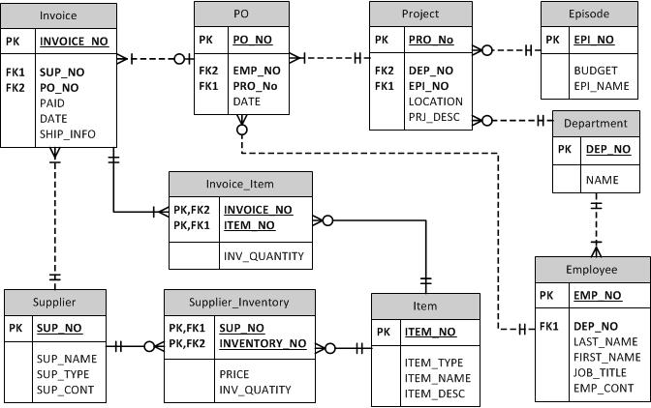

**Relationship**

PURCHASE_ORDER pays for INVOICE

    1:M, non-identifying (INVOICE is paid by PURCHASE_ORDER)

SUPPLIER creates INVOICE

   1:M,  non-identifying (INVOICE is created by SUPPLIER)

INVOICE contains INVOICE_ITEM

   1:M, identifying (INVOICE_ITEM must be contained by INVOICE)

SUPPLIER has SUPPLIER_INVENTORY

   1:M, identifying (SUPPLIER_INVENTORY must be of SUPPLIER)

INVENTORY describes INVOICE_ITEM

   1:M, identifying (INVOICE_ITEM must be described by INVENTORY)

INVENTORY describes SUPPLIER_INVENTORY

   1:M, identifying (SUPPLIER_INVENTORY must be described by INVENTORY)

EMPLOYEE authorises PURCHASE_ORDER

   1:M, non-identifying (PURCHASE_ORDER is authorised by EMPLOYEE)

PROJECT has PURCHASE_ORDER

   1:M, non-identifying (PURCHASE_ORDER is of PROJECT)

EMPLOYEE works on SHOW

   1:M, non-identifying (SHOW is worked on by EMPLOYEE)

SHOW has EPISODE

   1:M, non-identifying (EPISODE belong to SHOW)

EPISODE has PROJECT

   1:M, non-identifying (PROJECT belong to EPISODE)

**Attributes**

Episode: EPI_NO, EPI_NAME, BUDGET

Department: DEP_NO, DEP_NAME

Project: PRJ_NO, EPI_NO, DEP_NO, LOCATION, PRJ_DESC

Employee: EMP_NO,  DEP_NO, LAST_NAME, FIRST_NAME, JOB_TITLE, EMP_CONT

Purchase Order(PO):  PO_NO,  EMP_NO,  PRJ_NO, PO_DATE,

Invoice:  INV_NO,  SUP_NO,  PO_NO, INV_DATE, SHIP_INFO, PAID

Supplier:  Sup_NO, SUP_NAME, SUP_TYPE, SUP_CONT

Supplier_Inventory:   SUP_NO,  ITEM_NO, PRICE, SUP_QUANTITY

Invoice_Item:  INV_NO,  ITEM_NO , INV_QUANTITY

Item:  ITEM_NO, ITEM_NAME, ITEM_TYPE, ITEM_DESC

**Data Dictionary**

|  |  |  |  |  |  |
| --- | --- | --- | --- | --- | --- |
| Table | FieldName | Data type | Field length | Constraints | Description |
| Episode | EPI_NO | Varchar | 10 | Primary Key | Unique Identifier for Episode (PK) |
| Episode | EPI_NAME | Varchar | 50 | Not Null | Name of Episode |
| Episode | BUDGET | Decimal | 10,2 | Not Null | Amount of funds for Episode |
| Crew | PRJ_NO | Varchar | 10 | Primary Key, Foreign Key | Unique Identifier for Project(PK) |
| Crew | EMP_NO | Varchar | 10 | Primary Key, Foreign Key | Unique Identifier for Employees(PK) |
| Project | PRJ_NO | Varchar | 10 | Primary Key | Unique Identifier for Project (PK) |
| Project | EPI_NO | Varchar | 10 | Foreign Key | Reference to Unique Episode (FK) |
| Project | LOCATION | Varchar | 50 | Not Null | Location of Work for Project |
| Project | PRJ_DESC | Varchar | 5000 | Not Null | Description of Project |
| Employee | EMP_NO | Varchar | 10 | Primary Key | Unique Identifier for Employee (PK) |
| Employee | DEP_NAME | Varchar | 10 | Not Null | The departemnt of employees |
| Employee | LAST_NAME | Varchar | 20 | Not Null | Family Name of Employee |
| Employee | FIRST_NAME | Varchar | 20 | Not Null | Given Name of Employee |
| Employee | JOB_TITLE | Varchar | 20 | Not Null | Job Title of Employee |
| Employee | EMP_CONT | Varchar | 500 | Not Null | Employee Contact Information |
| Purchase Order(PO) | PO_NO | Varchar | 10 | Primary Key | Unique Identifier for PO (PK) |
| Purchase Order(PO) | EMP_NO | Varchar | 10 | Foreign Key | Reference to Unique Employee (FK) |
| Purchase Order(PO) | PRJ_NO | Varchar | 10 | Foreign Key | Reference to Unique Project (FK) |
| Purchase Order(PO) | PO_DATE | Date |  | Not Null | Creation Date of PO |
| Invoice | INV_NO | Varchar | 10 | Primary Key | Unique Identifier for Invoice (PK) |
| Invoice | SUP_NO | Varchar | 10 | Foreign Key | Reference to Unique Supplier (FK) |
| Invoice | PO_NO | Varchar | 10 | Foreign Key | Reference to Unique PO (FK) |
| Invoice | INV_DATE | Date |  | Not Null | Creation Date of Invoice |
| Invoice | SHIP_INFO | Varchar | 500 | Not Null | The destination of order item |
| Invoice | PAID | Decimal | 10,2 | Not Null | Payment Status of Invoice |
| Supplier | SUP_NO | Varchar | 10 | Primary Key | Unique Identifier of Supplier (PK) |
| Supplier | SUP_NAME | Varchar | 20 | Not Null | Name of Supplier |
| Supplier | SUP_TYPE | Varchar | 20 | Not Null | Type of Stock Carried |
| Supplier | SUP_CONT | Varchar | 500 | Not Null | Supplier Contact Information |
| Supplier_Inventory | SUP_NO | Varchar | 10 | Primary Key, Foreign Key | Reference to Unique Supplier (PK, FK) |
| Supplier_Inventory | ITEM_NO | Varchar | 20 | Primary Key, Foreign Key | Reference to Unique Item (PK, FK) |
| Supplier_Inventory | PRICE | Decimal | 10,2 | Not Null | Supplier's Unitary Price for Item |
| Supplier_Inventory | SUP_QUANTITY | Number |  | Not Null | Supplier's Stock Quantity |
| Invoice_Item | INVOICE_NO | Varchar | 10 | Primary Key, Foreign Key | Reference to Unique Invoice (PK, FK) |
| Invoice_Item | ITEM_NO | Varchar | 10 | Primary Key, Foreign Key | Reference to Unique Item (PK, FK) |
| Invoice_Item | INV_QUANTITY | Number |  | Not Null | Amount of Item Bought on Invoice |
| Item | ITEM_NO | Varchar | 10 | Primary Key | Unique Identifier for Item (PK) |
| Item | ITEM_NAME | Varchar | 20 | Not Null | Name of Item |
| Item | ITEM_TYPE | Varchar | 20 | Not Null | Type of Item |
| Item | ITEM_DESC | Varchar | 5000 | Not Null | Description of Item |

**Gantt Chart**

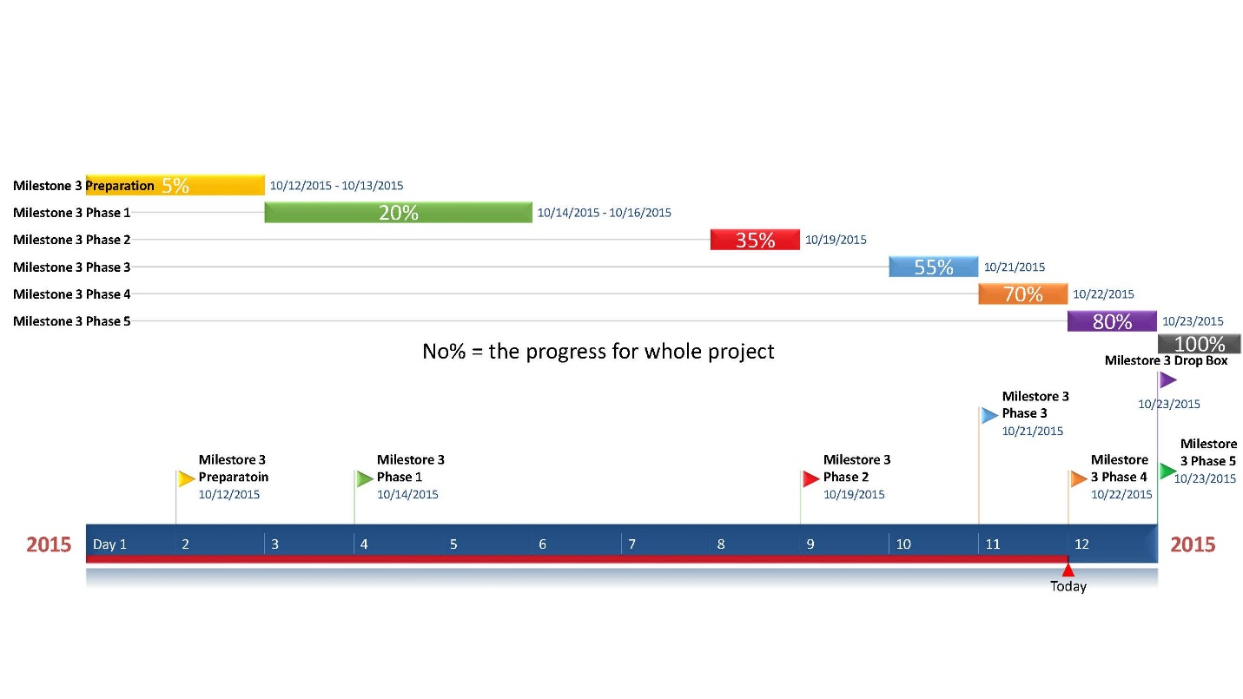

Document Information

|  |  |  |  |
| --- | --- | --- | --- |
| Project Name: | **ACIT1630 DB Project** | | |
| Project Manager: | York Liu |
| Prepared By: | York Liu |  |  |

1. Meeting Specifics

|  |  |  |  |  |  |  |
| --- | --- | --- | --- | --- | --- | --- |
| Type: | **Milestone3- phase 1** | | | | | |
| Purpose: | Ongoing information sharing and project status update | | | | | |
| Meeting Date: | 2015-10-14 | Start Time: | 2:30pm | | End Time: | 3:30pm |
| Meeting Host: | Zach | | Location: | Free table in Second floor SW 1 | | |
| Minute Taker: | York | |  |  | | |

1. Meeting Attendees

| Name |  | Attendance status | Position | Progress |
| --- | --- | --- | --- | --- |
| Andrew | | Yes | Team Leader | 20% |
| Zach Yu |  | Yes | Coordinator | 20% |
| Peter | | Yes | Team Member | 10% |
| York |  | Yes | Time Scheduler | 10% |

1. Agenda

| Id | Topic | Presenter | Times |
| --- | --- | --- | --- |
| 1 | Assign the task for each team member   |  | | --- | |  | | Zach and Andrew | 2015-10-14 |
| 2 | Append any updates to the detailed proposal   |  | | --- | |  | | Zach | 2015-10-14 |

1. Meeting Status Update and Results

Results Table

| No. | Subject/Description | Owner | Status & Progress |
| --- | --- | --- | --- |
| 1 | Review milestone 1 and 2 | All team member | Done |
| 2 | Make decision for each role of group member in milestone3  A, Zach will review and re-edit milestone2  B, Andrew will create entity and attributes, describe function and relationship for them  C, York will do project schedule and track progress with gantt chart  D, Peter will plan to draw ER diagram | All team member | In process |

Document Information

|  |  |  |  |
| --- | --- | --- | --- |
| Project Name: | **ACIT1630 DB Project** | | |
| Project Manager: | York Liu |
| Prepared By: | York Liu |  |  |

1. Meeting Specifics

|  |  |  |  |  |  |  |
| --- | --- | --- | --- | --- | --- | --- |
| Type: | **Milestone3- phase 2** | | | | | |
| Purpose: | Ongoing information sharing and project status update | | | | | |
| Meeting Date: | 2015-10-19 | Start Time: | 4:30pm | | End Time: | 5:30pm |
| Meeting Host: | Zach | | Location: | Meeting Room-2118-SW01 | | |
| Minute Taker: | York | |  |  | | |

2.Meeting Attendees

| Name |  | Attendance status | Position | Progress |
| --- | --- | --- | --- | --- |
| Andrew | | Yes | Team Leader | 50% |
| Zach Yu |  | Yes | Coordinator | 30% |
| Peter | | Yes | Team Member | 35% |
| York |  | Yes | Time Scheduler | 30% |

3.Agenda

| Id | Topic | Presenter | Time/Status |
| --- | --- | --- | --- |
| 1 | Review the feedback about milestone 2 from instructor Benjamin | Zach | 2015-10-19 |
| 2 | ER diagram discussion | All team member | 2015-10-19 |

4.Meeting Status Update and Results

Results Table

| No. | Subject/Description | Owner | Status & Process |
| --- | --- | --- | --- |
| 1 | Milestone 2 update  A, add two user stories | Zach | 50% finished , need to build another user stories |
| 2 | ER diagram discussion and update  A, Rebuild ER Diagram  B, Add at least three entity in the ER diagram.  C, Discuss the relationship among inventor, invoice and supplier | Peter  Zach , Andrew and York | In process |

Document Information

|  |  |  |  |
| --- | --- | --- | --- |
| Project Name: | **ACIT1630 DB Project** | | |
| Project Manager: | York Liu |
| Prepared By: | York Liu |  |  |

1.Meeting Specifics

|  |  |  |  |  |  |  |
| --- | --- | --- | --- | --- | --- | --- |
| Type: | **Milestone3- phase 3** | | | | | |
| Purpose: | Ongoing information sharing and project status update | | | | | |
| Meeting Date: | 2015-10-21 | Start Time: | 2:30pm | | End Time: | 3:30pm |
| Meeting Host: | Zach | | Location: | Meeting Room-2515-SW01 | | |
| Minute Taker: | York | |  |  | | |

2.Meeting Attendees

| Name |  | Attendance status | Position | Progress |
| --- | --- | --- | --- | --- |
| Andrew | | Yes | Team Leader | 70% |
| Zach Yu |  | Yes | Coordinator | 60% |
| Peter | | Yes | Team Member | 50% |
| York |  | Yes | Time Scheduler | 50% |

3.Agenda

| Id | Topic | Presenter | Time/Status |
| --- | --- | --- | --- |
| 1 | Task review for each team member | All team member | 2015-10-21 |
| 2 | project update | All team member | 2015-10-21 |

4.Meeting Status Update and Results

Results Table

| No. | Subject/Description | Owner | Status & Progress |
| --- | --- | --- | --- |
| 1 | A, Create online document for DB group ;  B, Share new edited with milestone2;  C, Zach will work with Peter to finish ERD  D, Zach will update the entity somewhat; | Zach | A, Done  B, Done  C, in process  D, in process |
| 2 | A, Update progress for each task ;  B, Gantt chart building is still on the way;  C, Report every cases happened in meeting; | York | A, Done  B, in process |
| 3 | Show and explain the relationship about each entity for the part of draw ERD, It includes PO Request, invoice, purchaser, supplier, inventory; | Peter | in process |
| 4 | A, Share understanding about whether or not the entity is necessary to add in the ERD;  B, Andrew will build relationship on the basis of Zach’s entity | Andrew | A, Done  B, in process |

Document Information

|  |  |  |  |
| --- | --- | --- | --- |
| Project Name: | **ACIT1630 DB Project** | | |
| Project Manager: | York Liu |
| Prepared By: | York Liu |  |  |

1.Meeting Specifics

|  |  |  |  |  |  |  |
| --- | --- | --- | --- | --- | --- | --- |
| Type: | **Milestone3- phase 4** | | | | | |
| Purpose: | Ongoing information sharing and project status update | | | | | |
| Meeting Date: | 2015-10-22 | Start Time: | 5:30pm | | End Time: | 6:30pm |
| Meeting Host: | Zach | | Location: | Meeting Room-2515-SW1 | | |
| Minute Taker: | York | |  |  | | |

2.Meeting Attendees

| Name |  | Attendance status | Position | Progress |
| --- | --- | --- | --- | --- |
| Andrew | | Yes | Team Leader | 75% |
| Zach Yu |  | Yes | Coordinator | 80% |
| Peter | | Yes | Team Member | 75% |
| York |  | Yes | Time Scheduler | 70% |

3.Agenda

| Id | Topic | Presenter | Time/Status |
| --- | --- | --- | --- |
| 1 | ER diagram discussion and update | All team member | 2015-10-22 |
| 2 | project review and update | All Team member | 2015-10-22 |

4.Meeting Status Update and Results

Results Table

| No. | Subject/Description | Owner | Status & Progress |
| --- | --- | --- | --- |
| 1 | Entity discussion  A, Delete previous entity “SHOW” ;  B, Add new entity “Department” in ERD;  C, analyse the relationship among each entity, it includes, Employee, Episode, Purchaser, Project, Invoice, Supplier, Invoice-item and Inventory; | All team member | A, Done  B, Done  C, Done |
| 2 | add new attribute for each entity | Andrew  Zach | Done |
| 3 | Andrew describe each attribute under entity; | Andrew | In process |
| 4 | A, Drew ERD through using Microsoft Viso  B, Delete useless user stories | Zach | Done |
| 5 | User stories update  A, Added new user story in milestone3 by peter;  B, added two new user stories by Andrew and one new user story by York | Peter  Andrew  York | Done |
| 6 | Data Dictionary discussion | Zach | In process  Zach will do the data dictionary |

Document Information

|  |  |  |  |
| --- | --- | --- | --- |
| Project Name: | **ACIT1630 DB Project** | | |
| Project Manager: | York Liu |
| Prepared By: | York Liu |  |  |

1.Meeting Specifics

|  |  |  |  |  |  |  |
| --- | --- | --- | --- | --- | --- | --- |
| Type: | **Milestone3- phase 5** | | | | | |
| Purpose: | Ongoing information sharing and project status update | | | | | |
| Meeting Date: | 2015-10-23 | Start Time: | 4:30pm | | End Time: | 5:30pm |
| Meeting Host: | Zach | | Location: | Meeting Room-2513 | | |
| Minute Taker: | York | |  |  | | |

2. Meeting Attendees

| Name |  | Attendance status | Position | Progress |
| --- | --- | --- | --- | --- |
| Andrew | | Yes | Team Leader | 100% |
| Zach Yu |  | Yes | Coordinator | 100% |
| Peter | | Yes | Team Member | 100% |
| York |  | Yes | Time Scheduler | 100% |

3.Agenda

| Id | Topic | Presenter | Time/Status |
| --- | --- | --- | --- |
| 1 | Project update | All team member | 2015-10-23 |
| 2 | edit each document and Final discussion (drop box ) | All team member | 2015-10-23 |

4.Meeting Status Update and Results

Results Table

| No. | Subject/Description | Owner | Status & Progress |
| --- | --- | --- | --- |
| 1 | Each attribute have been described | Andres | Done |
| 2 | Data dictionary will be done before the last meeting | Zach, Andres  Peter | In process |
| 3 | Project schedule file and Gantt chart will be done after the last meeting | York | In process |
| 4 | The ERD update and is completed over 90% by Zach and Peter | Zach and Peter | In process |

**Milestone4**

**a. Normalized ER diagram. Describe how the ER diagram in Milestone 3 is transformed to higher normalized forms.**

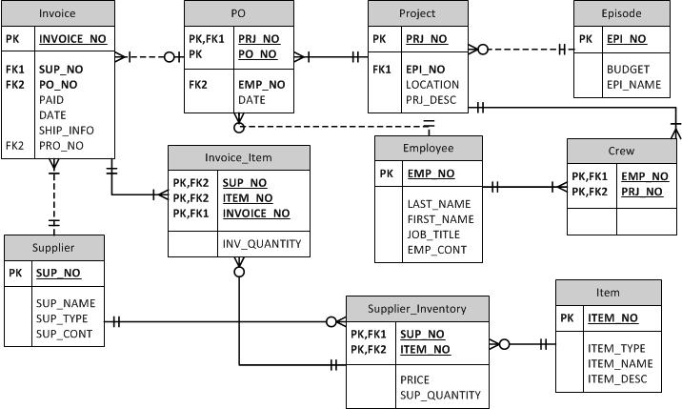

Our ER diagram was almost in the 3rd normalized form in milestone 3, we made a little change on the ER diagram. We removed department entity and added crew to represent the relationship between project and employee, and fixed the relationship between invoice item, item, and supplier inventory.

Our ER diagram are now checked for dependencies, we have identified primary keys and get rid of partial dependency, transitive dependency, and multi-valued. They are all just functional dependent on the primary keys.

**b. Sample Tables with actual data. Describe and give examples how information required by stakeholders in Milestone 1 and data sources in Milestone 2 are stored / retrieved from the tables.**

SELECT *

FROM Episode

|  |  |  |
| --- | --- | --- |
| EPI_NO | EPI_NAME | BUDGET |
| 1 | Flash01 | 1234567 |
| 2 | Flash02 | 803520 |
| 3 | Flash03 | 786932 |

3 rows selected. 0.00 seconds

SELECT *

FROM Supplier

|  |  |  |  |
| --- | --- | --- | --- |
| SUP_NO | SUP_NAME | SUP_TYPE | SUP_CONT |
| 1 | Crash Car | Equipment | 202-556-0303 |
| 2 | Sony professinal camera | Equipment | 202-556-0304 |
| 3 | A&W | Equipment | 202-556-0305 |
| 4 | Rent the Runway | Dress | 202-556-0306 |
| 5 | Nikon professional camera | Equipment | 202-556-0307 |
| 6 | The Hunting Ground | Place | 202-556-0308 |
| 7 | Solaway Travel Ltd | Travel | 202-556-0309 |
| 8 | Shiseido | Makeup | 202-556-0310 |
| 9 | Digital Capcom | Studio | 202-556-0311 |

9 rows selected. 0.01 seconds

SELECT *

FROM Project

|  |  |  |  |
| --- | --- | --- | --- |
| PRJ_NO | EPI_NO | LOCATION | PRJ_DESC |
| 1 | 1 | Vancouver | Driving scene around Cambie; 50 crew members |
| 2 | 2 | Los Angeles | A kissing scene in the rain with 30 crew members |

2 rows selected. 0.00 seconds

SELECT *

FROM Item

|  |  |  |  |
| --- | --- | --- | --- |
| ITEM_NO | ITEM_NAME | ITEM_TYPE | ITEM_DESC |
| 1 | Sports Cars | Equipment | Rental Lexus, BMW, Audi |
| 2 | 360 degree camera | Equipment | Sony professional 360 degree camera for movie |
| 3 | Mozo Combo | Food | beef burgers, french fries, roots beer |
| 4 | Markup set | Markup | professional cosmetic composition |
| 5 | Rooftop | place | The Mark Towers rooftop |
| 6 | Uncle Combo | Food | beef burgers, french fries, roots beer |

6 rows selected. 0.01 seconds

SELECT *

FROM Employee

|  |  |  |  |  |  |
| --- | --- | --- | --- | --- | --- |
| EMP_NO | DEP_NAME | LAST_NAME | FIRST_NAME | JOB_TITLE | EMP_CONT |
| 1 | Equipment | Vega | Andres | Technical Director | 202-555-0138 |
| 2 | Equipment | Fox | Akyssa | Equipment Maintence | 202-555-0130 |
| 3 | Photography | Jacobs | Verna | Leader of Photography | 202-555-0185 |
| 4 | Actors | Mills | Patrick | Supporting Actor | 202-555-0170 |
| 5 | Gaffers | Lee | Stan | Craft Service Person | 202-555-0198 |
| 6 | Stylist | Brooks | Marty | Makeup Artist | 202-555-0102 |
| 7 | Stage Manager | Blake | Lionel | Chief Stage Manager | 202-555-0232 |
| 8 | Stage Manager | Chen | Jacky | Chief Lighting Director | 202-555-0254 |
| 9 | Special Effects | Ray | Matt | Special FX | 202-555-0298 |
| 10 | Sound and Music | Fuller | Angel | Sound Engineer | 202-555-0276 |

10 rows selected. 0.01 seconds

SELECT *

FROM Crew

|  |  |
| --- | --- |
| PRJ_NO | EMP_NO |
| 1 | 1 |
| 1 | 2 |
| 1 | 3 |
| 1 | 4 |
| 1 | 5 |
| 1 | 6 |
| 1 | 7 |
| 1 | 8 |
| 1 | 9 |
| 2 | 10 |
| 2 | 3 |
| 2 | 4 |
| 2 | 5 |
| 2 | 6 |
| 2 | 7 |
| 2 | 8 |
| 2 | 9 |

17 rows selected. 0.01 seconds

SELECT *

FROM PO

|  |  |  |  |
| --- | --- | --- | --- |
| PO_NO | EMP_NO | PRJ_NO | PO_DATE |
| 1 | 2 | 1 | 11/17/2015 |
| 2 | 3 | 1 | 11/17/2015 |
| 3 | 5 | 1 | 11/17/2015 |
| 4 | 6 | 2 | 11/22/2015 |
| 5 | 7 | 2 | 11/22/2015 |
| 6 | 5 | 2 | 11/22/2015 |

6 rows selected. 0.01 seconds

SELECT *

FROM Invoice

|  |  |  |  |  |
| --- | --- | --- | --- | --- |
| INV_NO | SUP_NO | PO_NO | INV_DATE | SHIP_INFO |
| 1 | 1 | 1 | 11/18/2015 | Shipping to Vancouver |
| 2 | 3 | 3 | 11/18/2015 | Shipping to Vancouver |
| 3 | 2 | 2 | 11/18/2015 | Shipping to Vancouver |
| 4 | 8 | 4 | 11/22/2015 | Shipping to Los Angeles |
| 5 | 6 | 5 | 11/22/2015 | Shipping to Los Angeles |
| 6 | 3 | 6 | 11/22/2015 | Shipping to Los Angeles |

6 rows selected. 0.01 seconds

SELECT *

FROM Supplier_Inventory

|  |  |  |  |
| --- | --- | --- | --- |
| SUP_NO | ITEM_NO | PRICE | SUP_QUANTITY |
| 1 | 1 | 200000 | 3 |
| 2 | 2 | 100000 | 1 |
| 3 | 3 | 20 | 50 |
| 8 | 4 | 2000 | 2 |
| 6 | 5 | 100000 | 1 |
| 3 | 6 | 20 | 30 |

6 rows selected. 0.00 seconds

SELECT *

FROM Invoice_Item

|  |  |  |  |
| --- | --- | --- | --- |
| SUP_NO | INV_NO | ITEM_NO | INV_QUANTITY |
| 1 | 1 | 1 | 3 |
| 2 | 3 | 2 | 1 |
| 3 | 2 | 3 | 50 |
| 8 | 4 | 4 | 2 |
| 6 | 5 | 5 | 1 |
| 3 | 6 | 6 | 50 |

6 rows selected. 0.00 seconds

**c. Sample SQL statements. Describe and give examples of SQL statements used to store / access / update data in the database.**

SELECT INV_NO

FROM Invoice

|  |
| --- |
| INV_NO |
| 1 |
| 2 |
| 3 |
| 4 |
| 5 |
| 6 |

6 rows selected. 0.01 seconds

SELECT PO.PRJ_NO, SUM(price)

FROM Supplier_Inventory si INNER JOIN Invoice_Item bi

ON si.SUP_NO = bi.SUP_NO

AND si.ITEM_NO = bi.ITEM_NO

INNER JOIN Invoice inv

ON bi.INV_NO = inv.INV_NO

INNER JOIN PO

ON PO.PO_NO = inv.PO_NO

GROUP BY PO.PRJ_NO

|  |  |
| --- | --- |
| PRJ_NO | SUM(PRICE) |
| 1 | 300020 |
| 2 | 102020 |

2 rows selected. 0.01 seconds

SELECT SUP_TYPE

FROM Supplier

|  |
| --- |
| SUP_TYPE |
| Equipment |
| Equipment |
| Equipment |
| Dress |
| Equipment |
| Place |
| Travel |
| Makeup |
| Studio |

9 rows selected. 0.01 seconds

SELECT *

FROM PO

|  |  |  |  |
| --- | --- | --- | --- |
| PO_NO | EMP_NO | PRJ_NO | PO_DATE |
| 1 | 2 | 1 | 11/17/2015 |
| 2 | 3 | 1 | 11/17/2015 |
| 3 | 5 | 1 | 11/17/2015 |
| 4 | 6 | 2 | 11/22/2015 |
| 5 | 7 | 2 | 11/22/2015 |
| 6 | 5 | 2 | 11/22/2015 |

6 rows selected. 0.01 seconds

SELECT PO_NO, COUNT(INV_NO)

FROM Invoice

GROUP BY PO_NO

|  |  |
| --- | --- |
| PO_NO | COUNT(INV_NO) |
| 1 | 1 |
| 3 | 1 |
| 6 | 1 |
| 5 | 1 |
| 2 | 1 |
| 4 | 1 |

6 rows selected. 0.01 seconds

SELECT SHIP_INFO

FROM Invoice

WHERE PO_NO = '1'

|  |
| --- |
| SHIP_INFO |
| Shipping to Vancouver |

Statement processed. 0.01 seconds

SELECT PO_NO, to_date(PO_DATE, 'MM/DD/YYYY')

FROM PO

|  |  |
| --- | --- |
| PO_NO | TO_DATE(PO_DATE,'MM/DD/YYYY') |
| 1 | 11/17/2015 |
| 2 | 11/17/2015 |
| 3 | 11/17/2015 |
| 4 | 11/22/2015 |
| 5 | 11/22/2015 |
| 6 | 11/22/2015 |

6 rows selected. 0.00 seconds

SELECT (SELECT SUP_NAME

FROM Supplier

WHERE SUP_NO = '3'

) AS SUP_NAME,COUNT(INV_NO) AS INV_NUM

FROM Invoice

WHERE SUP_NO = '3' AND INV_DATE=to_date('22/11/2015','DD/MM/YYYY')AND SHIP_INFO NOT LIKE '%PICK UP%'

GROUP BY SUP_NO

|  |  |
| --- | --- |
| SUP_NAME | INV_NUM |
| A&W | 1 |

Statement processed. 0.02 seconds

SELECT EMP_NO, FIRST_NAME||LAST_NAME AS Name, DEP_NAME

FROM Employee

|  |  |  |
| --- | --- | --- |
| EMP_NO | NAME | DEP_NAME |
| 1 | AndresVega | Equipment |
| 2 | AkyssaFox | Equipment |
| 3 | VernaJacobs | Photography |
| 4 | PatrickMills | Actors |
| 5 | StanLee | Gaffers |
| 6 | MartyBrooks | Stylist |
| 7 | LionelBlake | Stage Manager |
| 8 | JackyChen | Stage Manager |
| 9 | MattRay | Special Effects |
| 10 | AngelFuller | Sound and Music |

10 rows selected. 0.01 seconds

SELECT ii.ITEM_NO, INV_QUANTITY, SUP_QUANTITY

FROM Invoice_Item ii LEFT JOIN Supplier_Inventory si

ON ii.ITEM_NO = si.ITEM_NO

AND ii.SUP_NO = si.SUP_NO

|  |  |  |
| --- | --- | --- |
| ITEM_NO | INV_QUANTITY | SUP_QUANTITY |
| 1 | 3 | 3 |
| 2 | 1 | 1 |
| 3 | 50 | 50 |
| 4 | 2 | 2 |
| 5 | 1 | 1 |
| 6 | 50 | 30 |

6 rows selected. 0.01 seconds

[Download](http://127.0.0.1:8080/apex/f?p=4500:1225:2307707549391995:FLOW_EXCEL_OUTPUT_R12089027223164064_en)

|  |  |
| --- | --- |
| Run By | ANDREW |
| Parsing Schema | KODIAK |
| Script Started | Friday, November 13, 2015 |
|  | 3 seconds ago |
| Elapsed time | 0.25 seconds |
| Statements Processed | 20 |
| Successful | 20 |
| With Errors | 0 |

**d. Referential Integrity. Describe and give examples of integrity constraints imposed on the data through relationships in Milestone 3 are implemented in the database.**

One foreign key in an entity would only refer to one another entity’s attribute which must be unique,  so it will not refer to something not exist or refer to one thing that is exact same as another. In our ER diagram, the foreign key will refer to other entity’s primary key which is unique and identical. For example, the item number 1 in supplier inventory entity, is exactly the refer to item number 1 in item entity, it will not be item number 2 or item number 3 or something not in the item entity.

**Gantt Chart**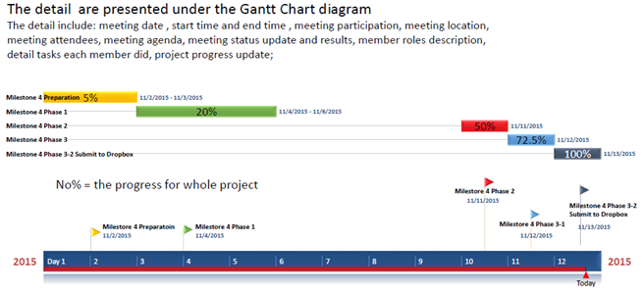

Document Information

|  |  |  |  |
| --- | --- | --- | --- |
| Project Name: | **ACIT1630 DB Project** | | |
| Project Manager: | York Liu |
| Prepared By: | York Liu |  |  |

1. Meeting Specifics

|  |  |  |  |  |  |  |
| --- | --- | --- | --- | --- | --- | --- |
| Type: | **Milestone4- phase 1** | | | | | |
| Purpose: | Ongoing information sharing and project status update | | | | | |
| Meeting Date: | 2015-11-04 | Start Time: | 4:30pm | | End Time: | 6:30pm |
| Meeting Host: | Zach | | Location: | Meeting Room-2187-SW01 | | |
| Minute Taker: | York | |  |  | | |

1. Meeting Attendees

| Name |  | Attendance status | Position | Progress |
| --- | --- | --- | --- | --- |
| Andrew | | Yes | Team Leader | 20% |
| Zach Yu |  | Yes | Coordinator | 20% |
| Peter | | Yes | Team Member | 20% |
| York |  | Yes | Time Scheduler | 20% |

1. Agenda

| Id | Topic | Presenter | Times |
| --- | --- | --- | --- |
| 1 | |  | | --- | |  |   Review and discuss the comments provided by the instructor on milestone 3 | All team member | 2015-11-04 |
| 2 | Assign the task of milestone 4 for each team member   |  | | --- | |  | | All team member | 2015-11-04 |

1. Meeting Status Update and Results

Results Table

| No. | Subject/Description | Owner | Status & Progress |
| --- | --- | --- | --- |
| 1 | Review milestone 3  A, change gantt chart format and make it more detail – handled by York  B, add Ship_info in the data dictionary and provide more details – handled by Zach  C, user story 10(delivery information) explanation - handled by Andrew | York  Zach  Andrew | In process |
| 2 | Make decision for each role of group member in milestone4  Peter--- 1), make change to previous milestones using Track Changes. 2), collect all the files (include all previous milestones) with track changes as appendices.  Zach---describe and give examples how information required by stakeholders in Milestone 1 and data sources in Milestone 2 are stored from the tables  Andrew---describe and give examples of SQL statements used to store data in the database  York---build Gantt chart, make schedule and report detail that happen in every meeting. | All team member | In process |

Document Information

|  |  |  |  |
| --- | --- | --- | --- |
| Project Name: | **ACIT1630 DB Project** | | |
| Project Manager: | York Liu |
| Prepared By: | York Liu |  |  |

1. Meeting Specifics

|  |  |  |  |  |  |  |
| --- | --- | --- | --- | --- | --- | --- |
| Type: | **Milestone4- phase 2** | | | | | |
| Purpose: | Ongoing information sharing and project status update | | | | | |
| Meeting Date: | 2015-11-11 | Start Time: | 2:30pm | | End Time: | 4:30pm |
| Meeting Host: | Zach | | Location: | Meeting Room-2187-SW01 | | |
| Minute Taker: | York | |  |  | | |

2.Meeting Attendees

| Name |  | Attendance status | Position | Progress |
| --- | --- | --- | --- | --- |
| Andrew | | Yes | Team Leader | 60% |
| Zach Yu |  | Yes | Coordinator | 50% |
| Peter | | Yes | Team Member | 40% |
| York |  | Yes | Time Scheduler | 50% |

3.Agenda

| Id | Topic | Presenter | Time/Status |
| --- | --- | --- | --- |
| 1 | Review and update the task that assigned last meeting | Zach | 2015-11-11 |
| 2 | Go through all the task team completed and make plan & schedule for next meeting | All team member | 2015-11-11 |

4.Meeting Status Update and Results

Results Table

| No. | Subject/Description | Owner | Status & Process |
| --- | --- | --- | --- |
| 1 | SQL statement update | Andrew |  |
| 2 | User story update :  1) delete the parts of “what else needs to purchase” in user story 5  2) delete user story 12 | Andrew , Peter | In process |
| 3 | Normalize ER Diagram :  1)Add new attributes for both entity supplier_Inventory and Invoice_Item---by Zach  2)make new connection between entity supplier_Inventory and Invoice_Item---by Zach and Andrew  3) use new entity “Crew” to replace old entity “Department” and build new relationship among “Crew” ”Project” ”Employee” :  Project : Crew ---- 1:M  Employee : Crew ---- 1:M  By Zach, Peter and Andrew | Zach, Peter, Andrew | In process |
| 4 | Go through all the task:  1) all files is going to be collected by Peter and make Track changes;  2) Describe how the ER diagram in Milestone 3 is transformed to higher normalized forms by Peter  3) build sample table with actual data (this part need to update again later) by Zach  4) rebuild data dictionary by Zach  5) SQL statement update(include entity description) by Andrew  6) Gantt chart is in process according to the progress in each meeting | All team member | In process |
| 5 | Referential Integrity discussion :  Definition analyze , by peter  More task in Referential Integrity will be schedule on 12th Nov 2015 | All team member | In process |

Document Information

|  |  |  |  |
| --- | --- | --- | --- |
| Project Name: | **ACIT1630 DB Project** | | |
| Project Manager: | York Liu |
| Prepared By: | York Liu |  |  |

1.Meeting Specifics

|  |  |  |  |  |  |  |
| --- | --- | --- | --- | --- | --- | --- |
| Type: | **Milestone4- phase 3-1** | | | | | |
| Purpose: | Ongoing information sharing and project status update | | | | | |
| Meeting Date: | 2015-11-12 | Start Time: | 5:30pm | | End Time: | 7:30pm |
| Meeting Host: | Zach | | Location: | Burnaby SE14 Library – 250C | | |
| Minute Taker: | York | |  |  | | |

2.Meeting Attendees

| Name |  | Attendance status | Position | Progress |
| --- | --- | --- | --- | --- |
| Andrew | | Yes | Team Leader | 80% |
| Zach Yu |  | Yes | Coordinator | 70% |
| Peter | | Yes | Team Member | 70% |
| York |  | Yes | Time Scheduler | 70% |

3.Agenda

| Id | Topic | Presenter | Time/Status |
| --- | --- | --- | --- |
| 1 | Task review for each team member and check the progress for whole project | All team member | 2015-11-12 |
| 2 | Discuss the task which exist problem and make solution | All team member | 2015-11-12 |

4.Meeting Status Update and Results

Results Table

| No. | Subject/Description | Owner | Status & Progress |
| --- | --- | --- | --- |
| 1 | user story 12 and the parts of “what else needs to purchase” in user story 5 have already deleted by Peter | Peter | Done |
| 2 | ER Diagram Normalization | Zach | Done |
| 3 | Sample data for SQL form is in processing. | Zach | In process |
| 4 | SQL statement have done by Andrew | Andrew | Done |
| 5 | Referential Integrity will be handled by Peter | Peter | In process |
| 6 | Gantt chart update for milestone 4 | York | In process |

Document Information

|  |  |  |  |
| --- | --- | --- | --- |
| Project Name: | **ACIT1630 DB Project** | | |
| Project Manager: | York Liu |
| Prepared By: | York Liu |  |  |

1.Meeting Specifics

|  |  |  |  |  |  |  |
| --- | --- | --- | --- | --- | --- | --- |
| Type: | **Milestone4- phase 3-2** | | | | | |
| Purpose: | Ongoing information sharing and project status update | | | | | |
| Meeting Date: | 2015-11-13 | Start Time: | 3:30pm | | End Time: | 5:30pm |
| Meeting Host: | Zach | | Location: | Free table-2 Floor-SW1 | | |
| Minute Taker: | York | |  |  | | |

2.Meeting Attendees

| Name |  | Attendance status | Position | Progress |
| --- | --- | --- | --- | --- |
| Andrew | | Yes | Team Leader | 100% |
| Zach Yu |  | Yes | Coordinator | 100% |
| Peter | | Yes | Team Member | 100% |
| York |  | Yes | Time Scheduler | 100% |

3.Agenda

| Id | Topic | Presenter | Time/Status |
| --- | --- | --- | --- |
| 1 | Update the unfinished task | All team member | 2015-11-13 |
| 2 | Collect all the file and update to the new version | Peter | 2015-11-13 |
| 3 | Gantt Chart update | York | 2015-11-13 |

4.Meeting Status Update and Results

Results Table

| No. | Subject/Description | Owner | Status & Progress |
| --- | --- | --- | --- |
| 1 | Sample data for SQL form update | Zach | Done |
| 2 | Referential Integrity update | Peter | Done |
| 3 | Collect all the project file from all team member to one document | Peter | Done |